Desktop Virtualization

**Introduction**

**Objective**

**CompTIA A + (220-1101) Domain:**  
Domain 4.0: Virtualization and Cloud Computing

**CompTIA A+ (220-1001) Objective:**  
Objective 4.1: Summarize cloud-computing concepts  
Objective 4.2: Summarize aspects of client-side virtualization

**Overview**

This lab is an introduction to desktop virtualization. We live in a virtualized world. Everything is virtualized from virtual worlds to virtual computers. Desktop virtualization is the ability to run multiple OSs on your computer. You need to have decent RAM and hard disk space to do virtualization appropriately. It is suggested to have a computer with 16 GB of RAM with a 1 TB hard drive if you are going to do a lot of virtualization.

In this lab, students will learn how to use desktop virtualization in Windows.

**Outcomes**

In this lab, you will learn to:

1. Install and configure desktop virtualization
2. Create and configure a virtual machine
3. Download, install and configure Windows XP mode

|  | **Key Term** | **Description** |
| --- | --- | --- |
| **1** | ISO Image | ISO image is a special file that contains a bootable CD image that allows you to mount to a virtual machine to install operating systems. |
| **2** | Virtual Machine | A virtual machine is a virtual representation of a computer. It allows a host machine to host multiple virtual machines. A virtual machine emulates hardware such as RAM, hard disks, CD ROM drives, etc. |

Desktop Virtualization

**Reading Assignment**

**Introduction**

A virtual machine, or VM, is a computer running in virtualization software instead of using physical hardware like a traditional operating system. A virtual machine is a great way to install, configure, and test operating systems for learning purposes. However, virtual machines are for far more than learning and testing. Virtual machines are typically part of large data centers and ever-present cloud environments. In this lab, you will set up two different types of virtual environments, including using the XP mode feature in Windows 7 and installing a Windows 10 Virtual Machine using Hyper-V on Windows 10. The XP mode feature allows you to run the older Windows XP operating system on a Windows 7 system. You will also get a chance to install and configure the Windows 10 operating system in Hyper-V, the virtualization software included with some versions of the Windows operating systems. To use any type of virtualization software, the use of virtualization needs to be enabled within the host computer’s BIOS (Basic Input Output System). The host computer is the physical computer where the operating system is running. This lab walks you through the installation process of Hyper-V on a machine running Windows 10.

**Windows XP Mode**

In this lab, you will install the Windows XP mode feature available for the Windows 7 operating system. Although both operating systems are no longer supported by Microsoft, they still are both used in some cases by individual users or organizations. This could be because a specific piece of software or hardware will not run on newer operating systems like Windows 10. Regardless, setting up the Windows XP mode feature, as seen in Figure 1, walks you through how to create a virtual machine for use on a host Windows 7 computer.

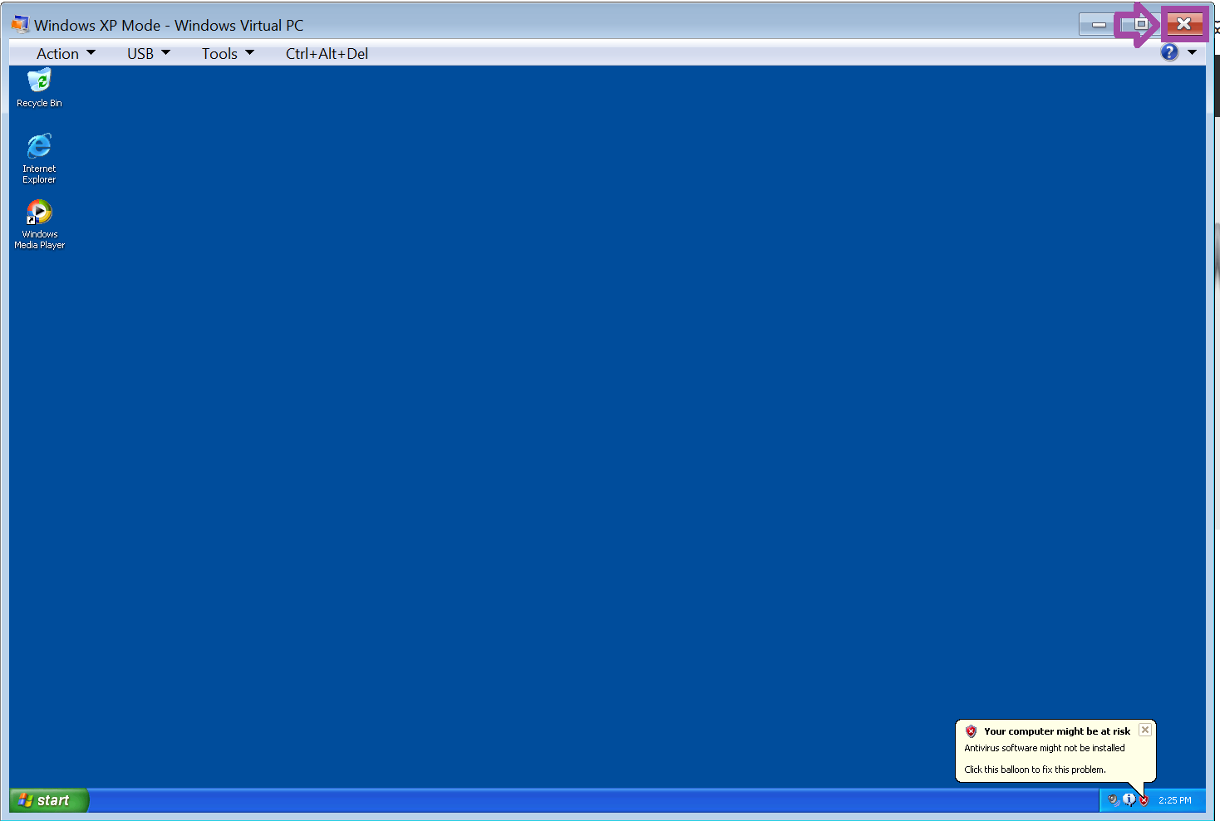

**Hyper-V Manager**

In this lab, you will use Hyper-V by Microsoft on the client operating system Windows 10. Hyper-V is a feature on some versions of Microsoft Windows that can be added to the operating system through the Add/Remove Windows Features applet in the Control Panel. In order to use Hyper-V on your computer running Windows, the use of virtualization needs to be enabled within the computer’s BIOS (Basic Input Output System). Hyper-V Manager, as seen in Figure 2, is where you go to install, configure, and manage virtual machines.

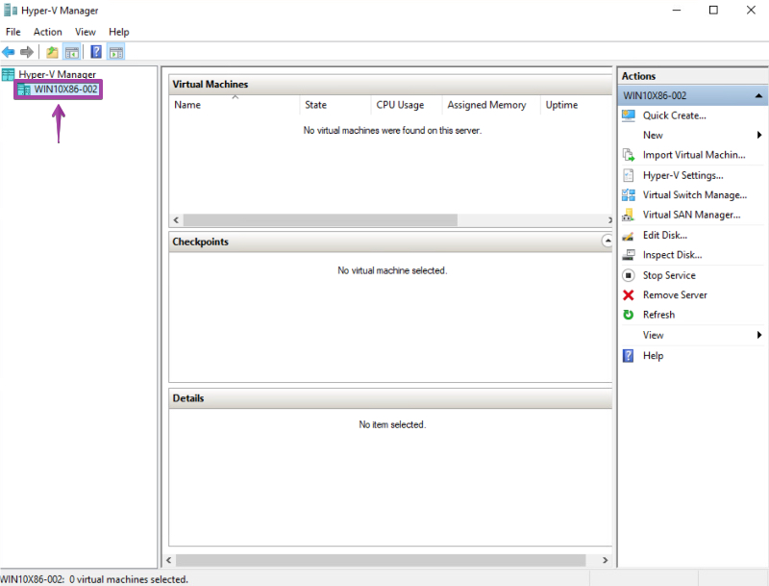

**Building A Virtual Machine**

When you create a virtual machine in Hyper-V Manager, you will need to specify the amount of disk space you want to allocate for the virtual machine, the amount of RAM and CPU. You can decide if you want to allocate all the disk space initially or let the amount of disk space grow over time as the virtual machine grows. Give sufficient RAM and CPUs to the VM to perform well but divide your resources adequately between the host and virtual machines. In Figure 3, you can see an example of allocating 1 GB of RAM to the Hyper-V virtual machine. You will need to check the specifications of the operating system to make sure you have not exceeded any memory processor limitations as this can cause the virtual machine to misfunction or become inoperable. Typically, a server operating system like Windows Server 2019 has a far greater capacity for the number of CPUs that can be used compared to a client operating system like Windows 10, which has a limit of CPUs.

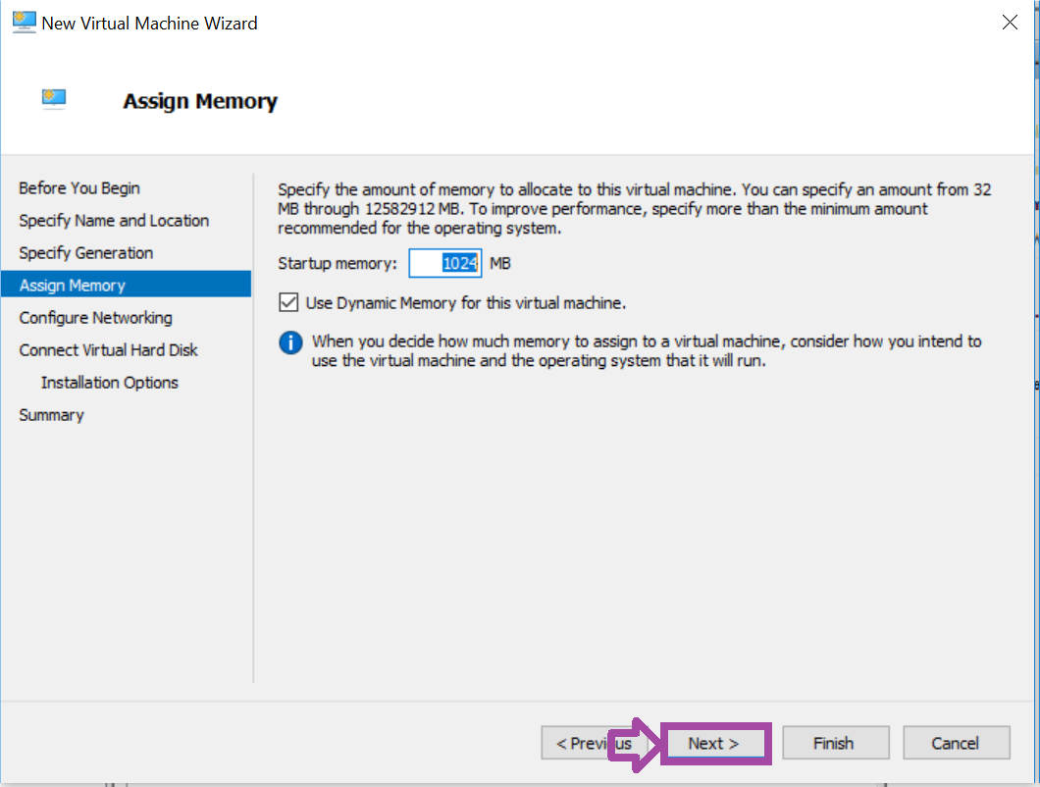

One nice feature of Hyper-V virtual machines is that you can use DVD images, referred to as ISO files. We will use this feature and point to the Windows 10 installation DVD on the host computer running the Windows 10 operating system. From there, we can install Windows 10 to the virtual machine using the same steps and techniques we would use for installing the operating system for a physical computer.

**Summary**

Windows XP mode is a valuable feature if you want to run older software.  Though Windows 7 and Windows XP are no longer supported by Microsoft, they are still in use in many situations, since some programs will not run in newer versions of windows. Windows 10 is the primary client operating system for Microsoft in use today. In this lab, you will utilize Hyper-V to create a Windows 10 Virtual Machine.

**Installing and Configuring Virtual PC in Windows 7**

Virtual PC is Windows 7 virtualization hypervisor. You will install the hypervisor and then install Windows 7 in the hypervisor.

**Installing Virtual PC**

1. **Click** on Windows 7 machine in the topology.

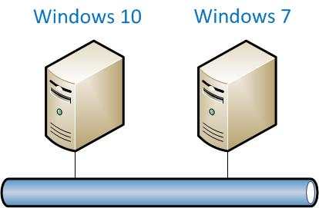

Note:  If you are asked for an activation key, simply click "Ask me later".

1. **Click**on Windows File Explorer.  
     
   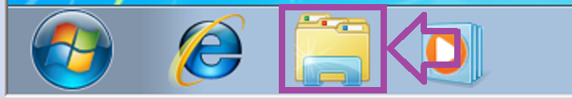
2. **Double click** Documents Library.

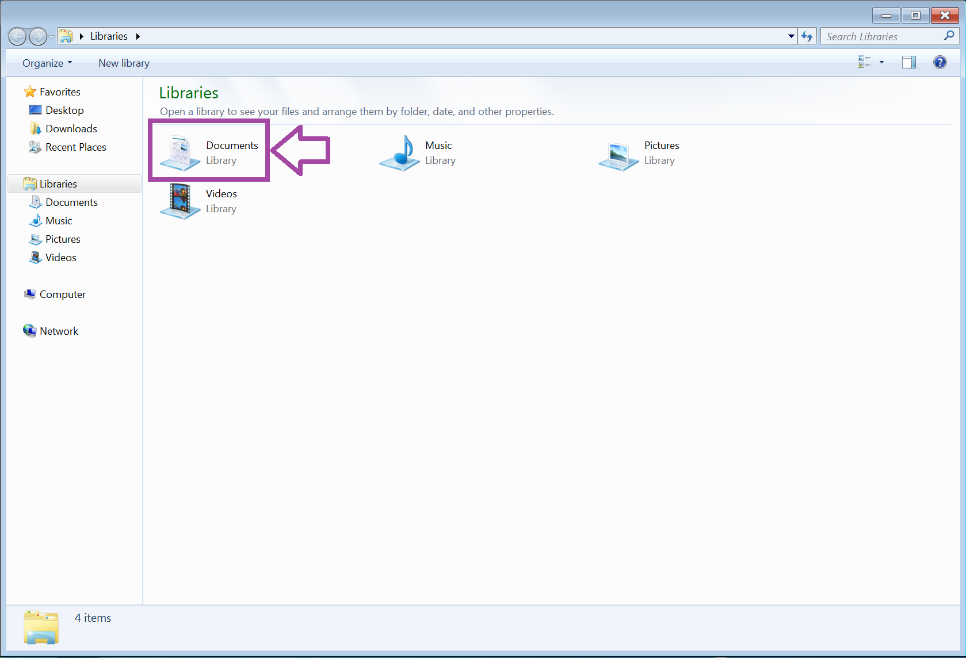

1. **Double click** on the sampleflag in the Documents folder.

SAMPLE CHALLENGE

1. **Double click** on Windows6.1-KB958559-x64-RefreshPkg to launch the Virtual PC Installation.

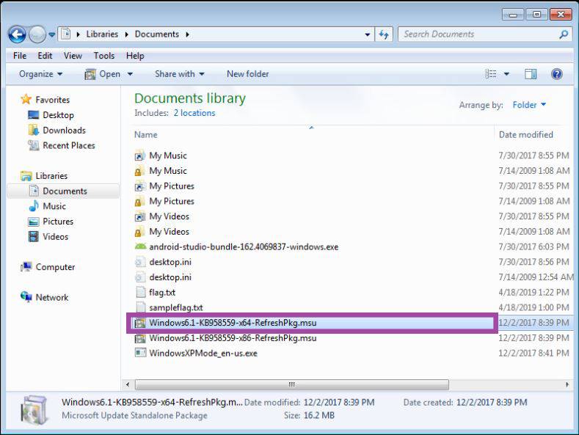

1. **Click** on Yes to launch installer.

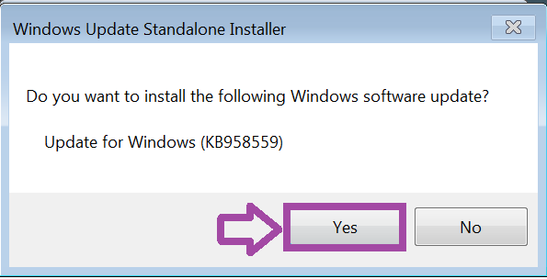

1. **Click** on I Accept.

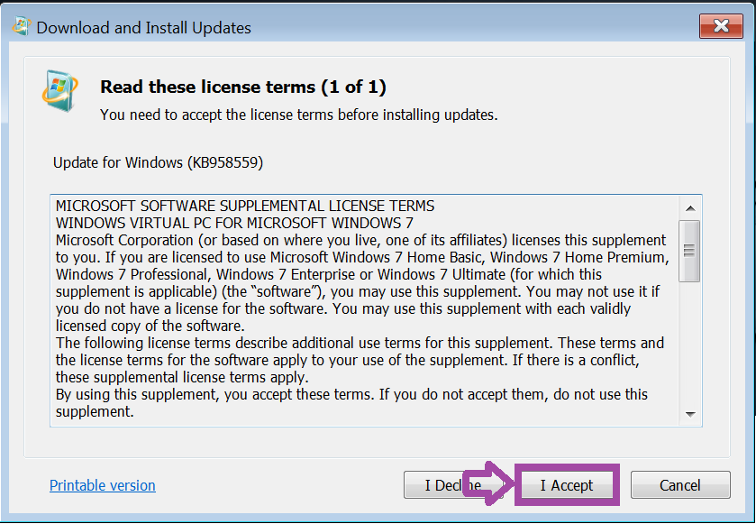

1. When the installation completes,**click** Restart Now.

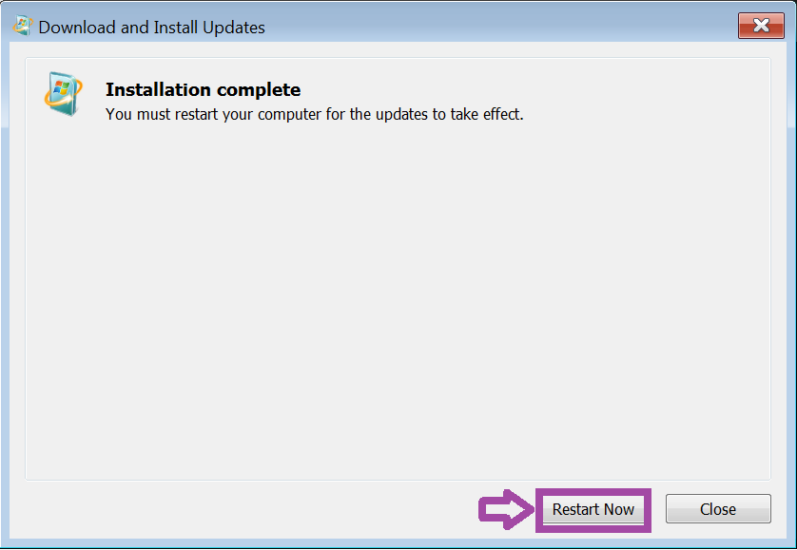

1. If you are asked to login again, the password is Password1.

CHALLENGE #1

**Configure A Virtual Machine In Windows 7**

1. **Click** on the Start menu.

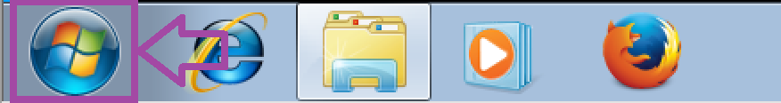

1. **Click** on Windows Virtual PC to launch the application.

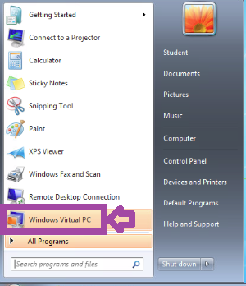

1. **Click** on Create virtual machine to create a virtual machine.

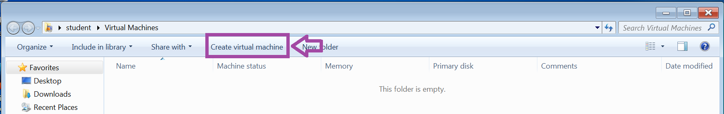

1. **Type** Windows7 in the Name text box.

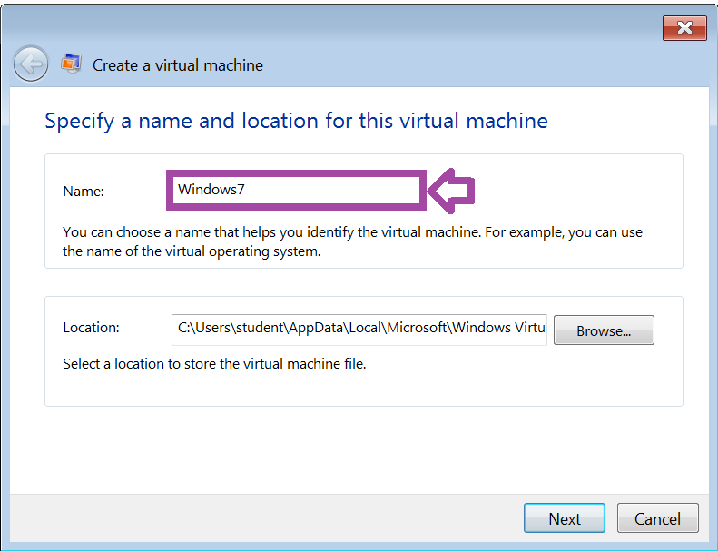

1. **Click** on Next.

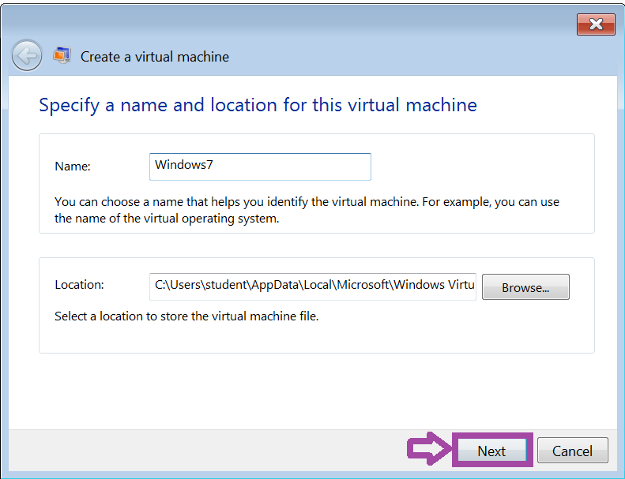

1. **Click** on Next.

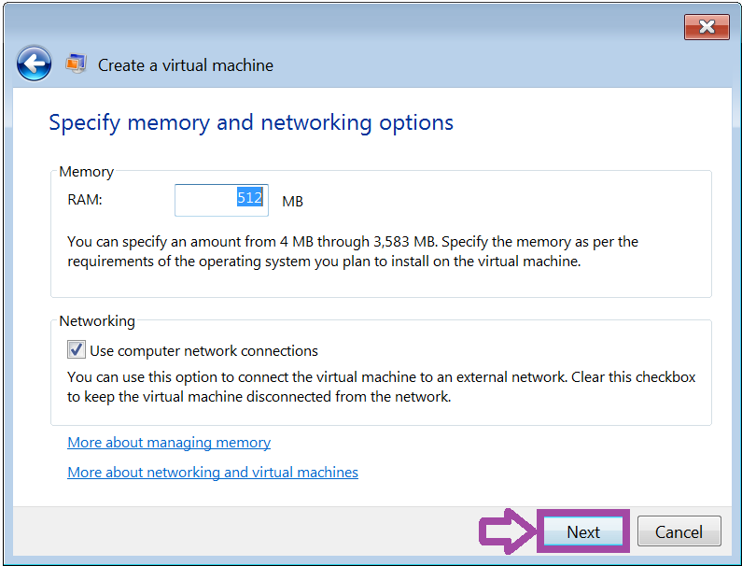

1. **Click** on Create to create the virtual machine.

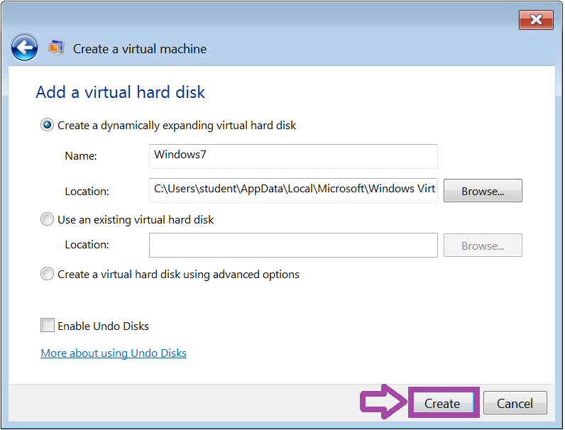

1. **Right-click** the Windows 7 virtual machine.

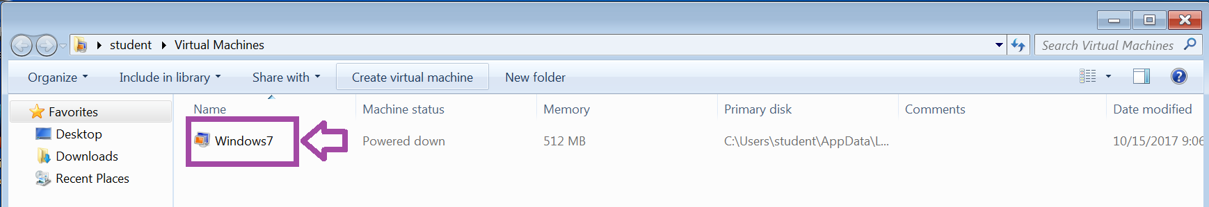

1. **Click** on Settings.

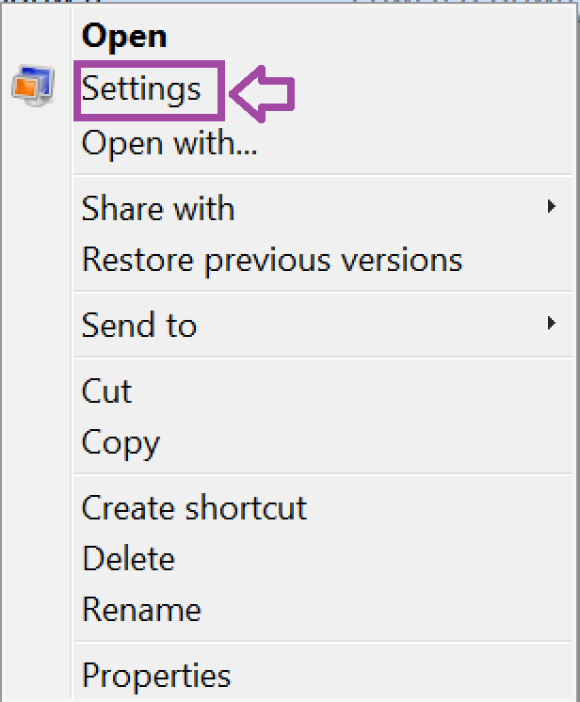

You are going to install Windows 7 into a virtual machine. To do so, you need to configure the virtual DVD/CDROM drive to an ISO image of Windows 7. ISO images are special images that when mounted, act as a CDROM drive.

1. **Click** on DVD Drive. **Click** the radio button for Open an ISO image.  **Click** the Browse button.

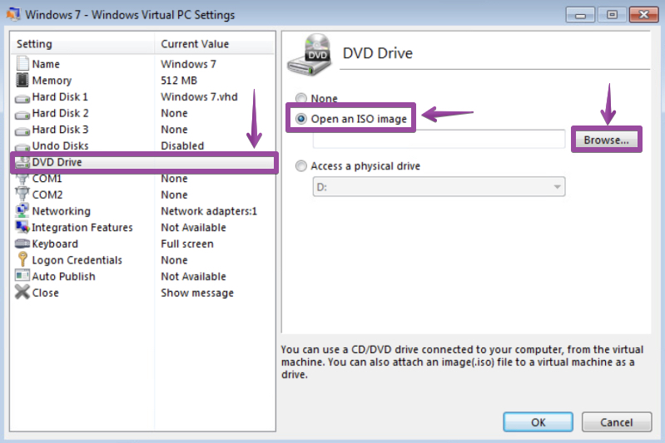

1. You would select an iso which is an image to install an Operating System. You will install several operating systems in the next series of labs. **Click** cancel.

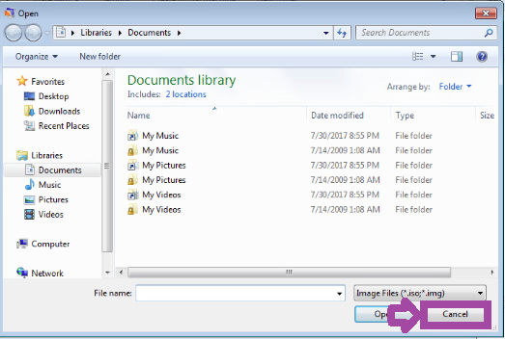

1. **Click**on None.  
   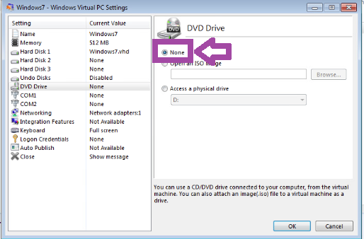
2. **Click** on OK.  
   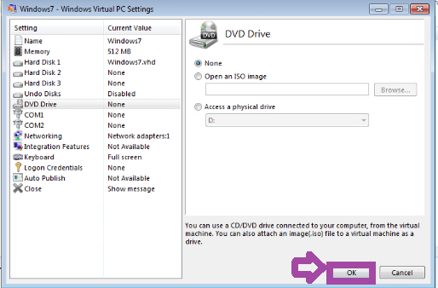
3. **Right-click** on Windows7 VM.

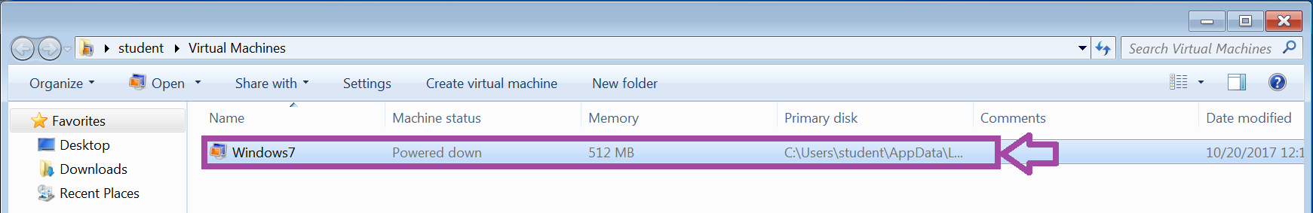

1. **Click** on Delete.

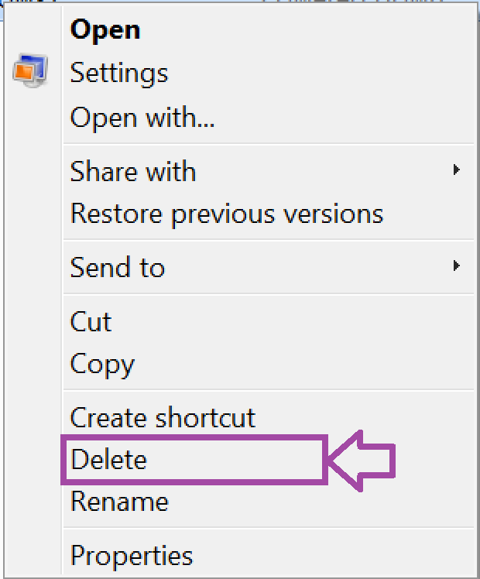

1. **Click** on Yes.

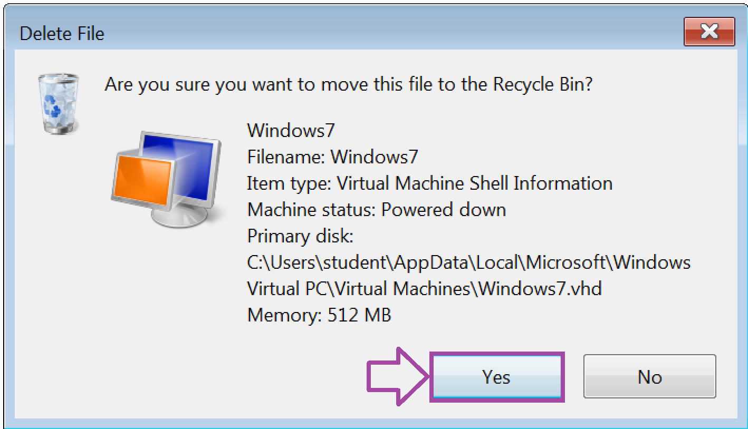

1. **Right-click** on Recycle Bin.



1. **Click** on Empty Recycle Bin.

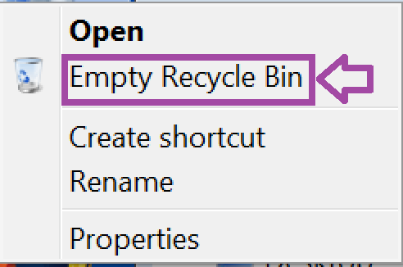

1. **Click** on Yes. Your screen might look different depending on how many files are in the Recycle Bin.

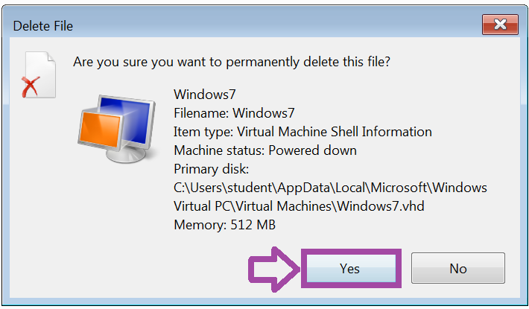

1. **Click** on the X button to close the Window.

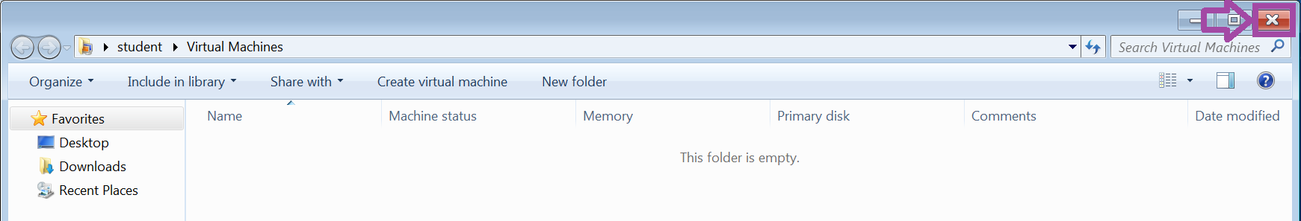

**Conclusion**

This section installed Virtual PC in a Windows 7 computer.

This section created and deleted a virtual machine in Virtual PC and mounted an ISO image of Windows 7 to install.

**Discussion Questions**

1. What is a Virtual PC?
2. What is a Virtual Machine?
3. What is an ISO image?
4. What is the RAM configuration for a virtual machine?

**Installing and Configuring Windows XP Mode in Windows 7**

Windows XP mode is a virtual machine that allows you to run program that run on Windows XP directly from a computer that runs Windows 7.

**Install Windows XP Mode**

1. **Click** on Windows File Explorer.  **Double-click** the Documents icon.



1. **Double click** WindowsXPMode_en-us to launch Windows XP Mode installation program.

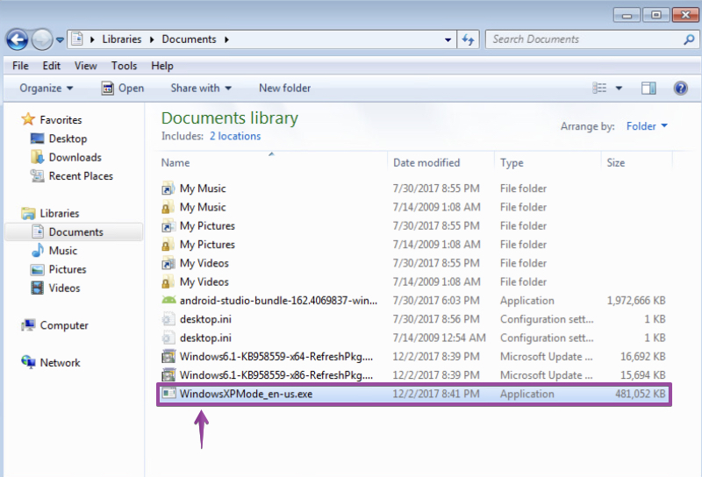

CHALLENGE #2

1. **Click** on Run.

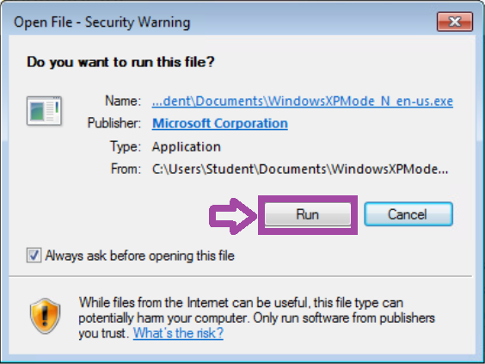

1. The setup program will start. **Click** on Next.

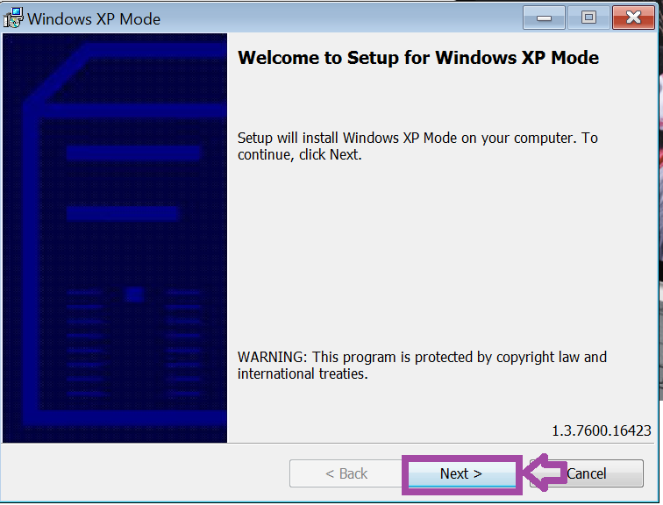

1. **Click** on Next.

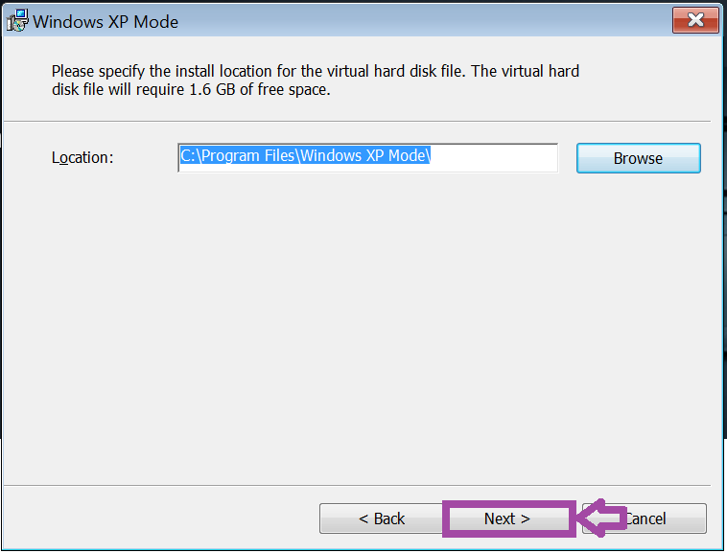

1. If asked,**click** on Yes.

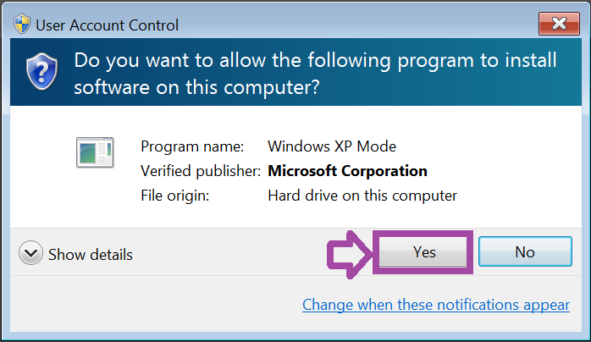

Note: The virtual hard disk file will install.

1. **Click** on Finish to launch Window XP Mode.

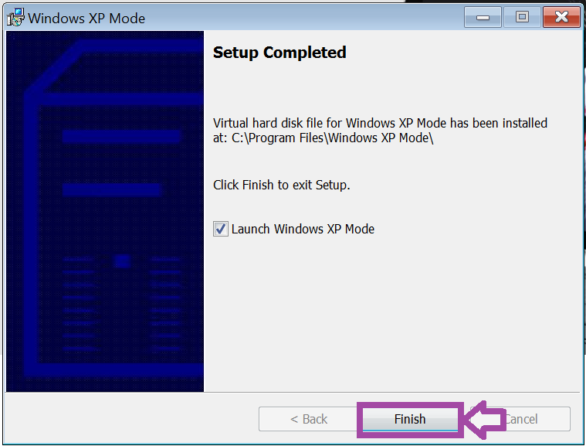

1. **Click** on I accept the license terms.

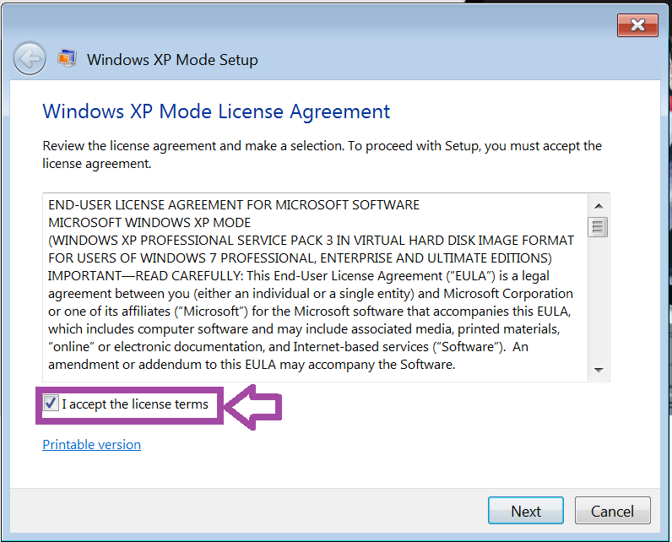

1. **Click** on Next.

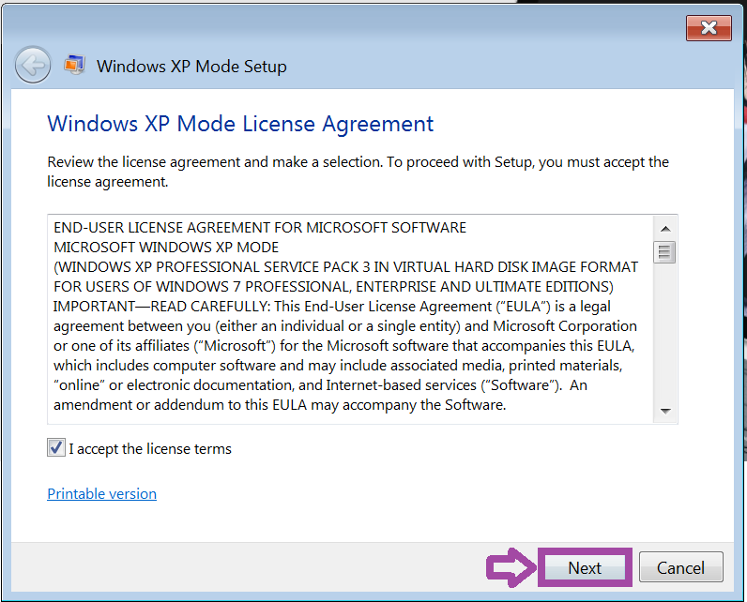

1. **Type** Password1 in the Password text box.

Note: The password of **Password1** will not be displayed when you type it for security purposes.

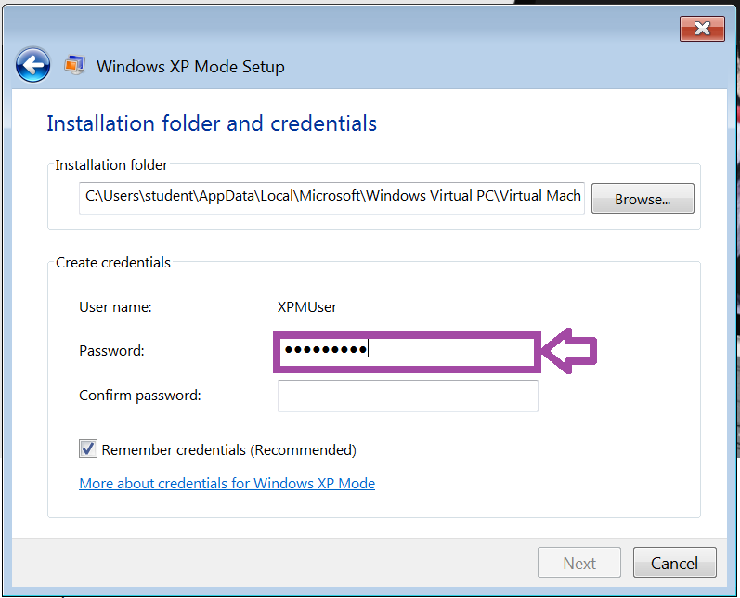

1. **Type** Password1 in the Confirm password text box.

Note: The password of **Password1** will not be displayed when you type it for security purposes.

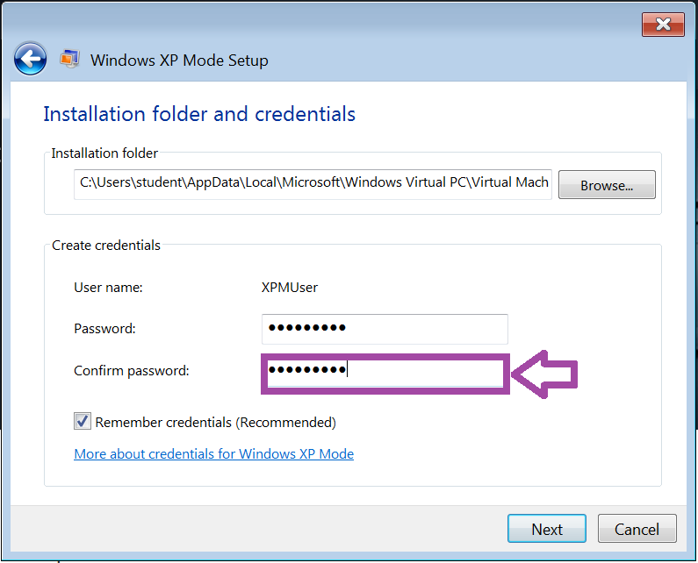

1. **Click** on Next.

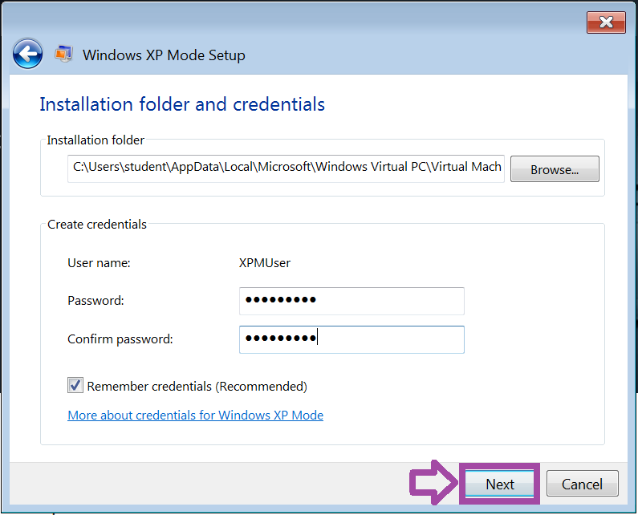

1. **Click** on Not right now. The best practice would be to select the first option, but for this lab, we do not want to add more traffic to the network that slow things down.

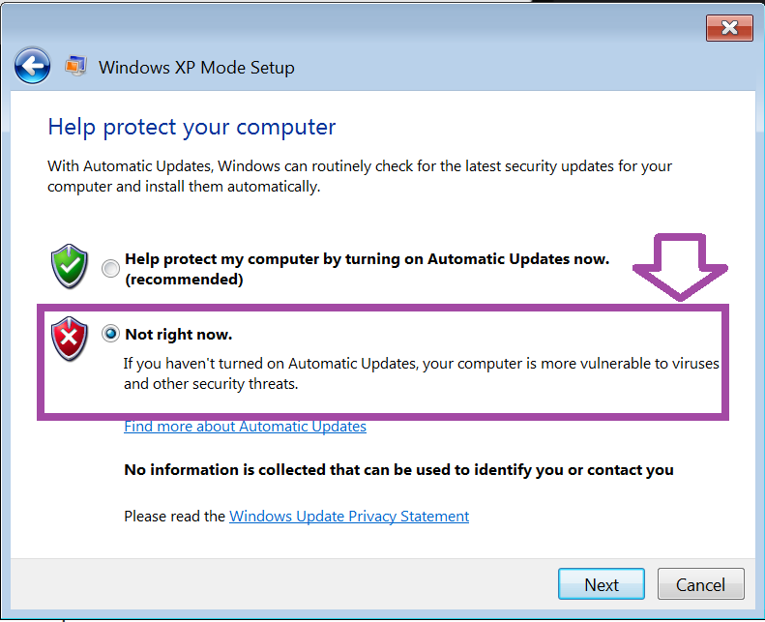

1. **Click** on Next.

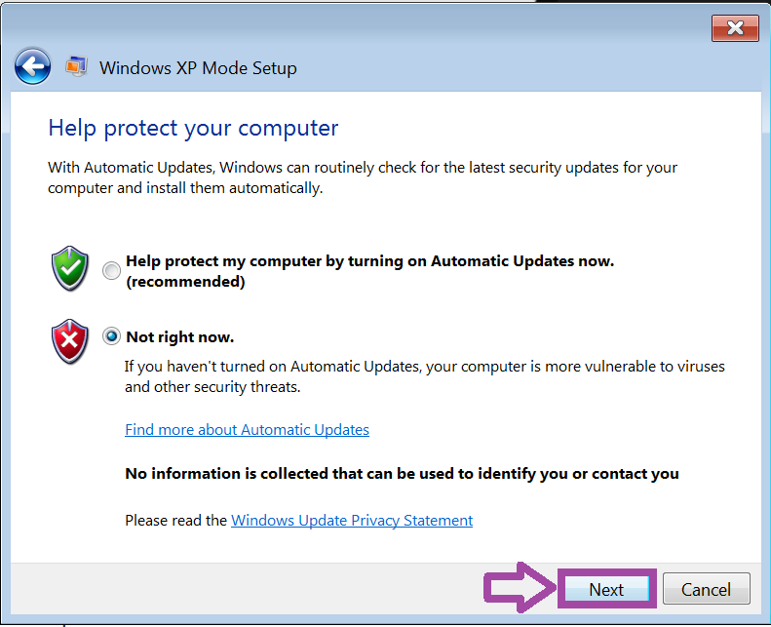

1. **Click** on Start Setup.

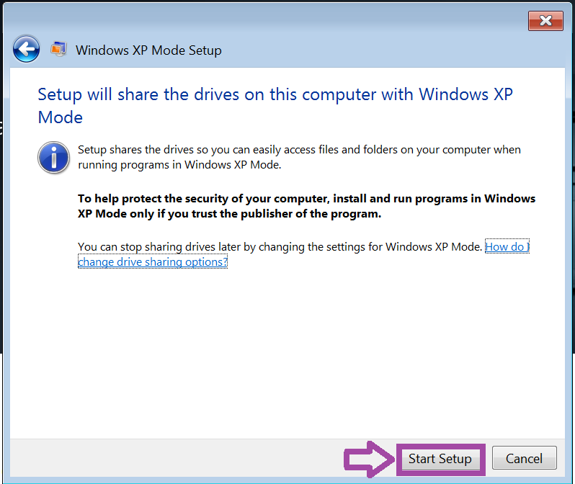

Windows XP Mode will now install.  This may take 5 minutes. Congratulations, you now have Windows XP running on your Windows 7 machine.

1. **Click** on the X button to close the virtual machine.

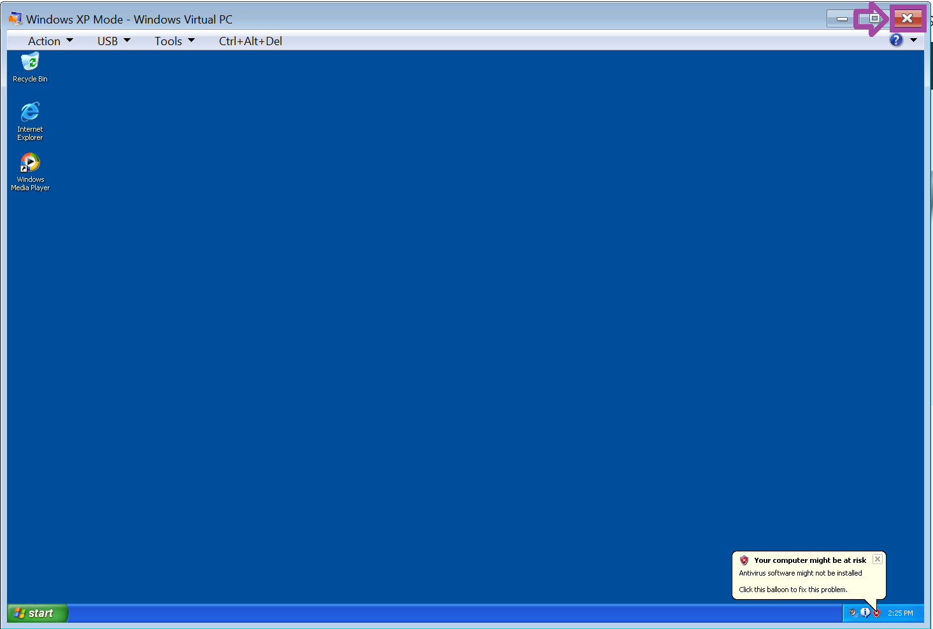

**Conclusion**

This section created a virtual machine in Virtual PC for Windows XP Mode.

**Discussion Questions**

1. What is Windows XP Mode in Windows 7?
2. Why is it important?

**Installing and Configuring Hyper-V in Windows 10**

Hyper-V is Microsoft’s virtualization technology that allows for virtualizing clients and servers.

**Enable Hyper-V In Windows 10**

1. **Click** on Windows 10 machine in the topology.



1. **Click**on the screen saver to log in.  Your screen saver might look different.

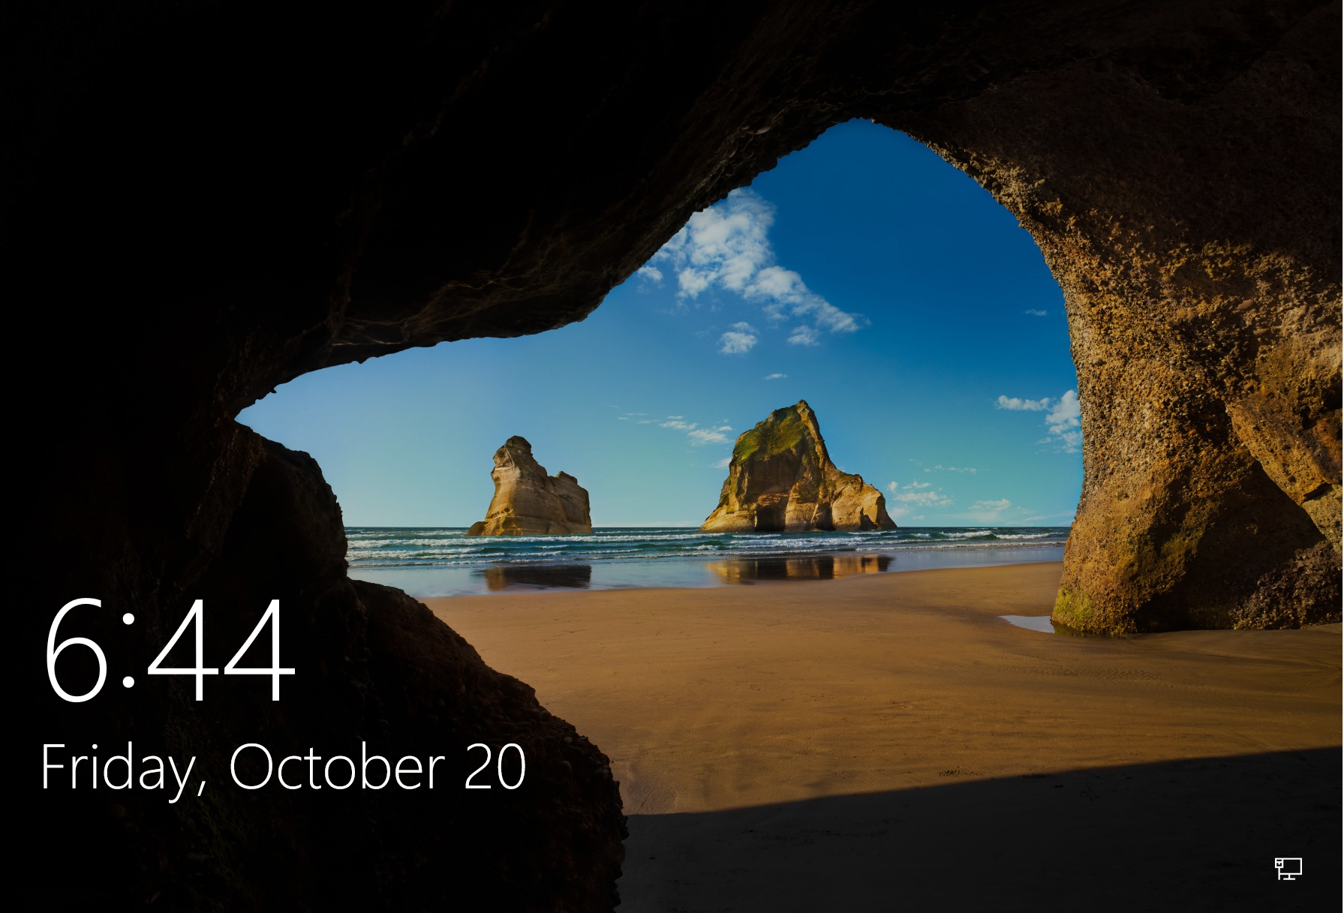

1. **Log on** to Windows as student with the password of Password1. **Press** Enter.

Note: The password of **Password1** will not be displayed when you type it for security purposes.

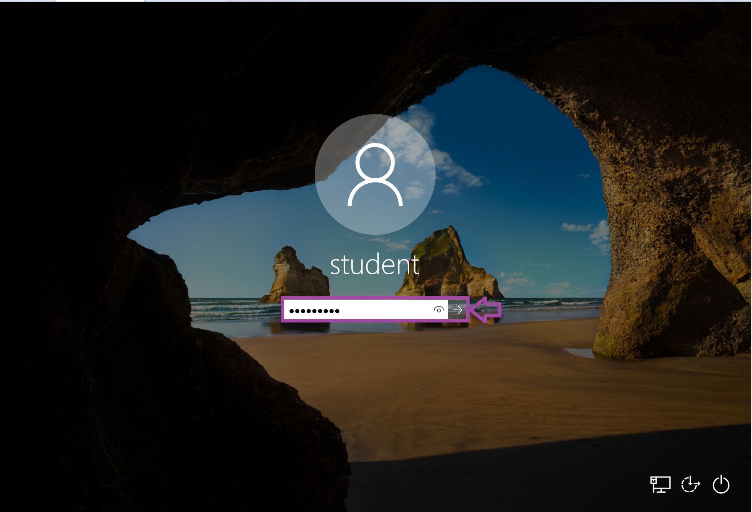

1. **Click**in the Search Box.

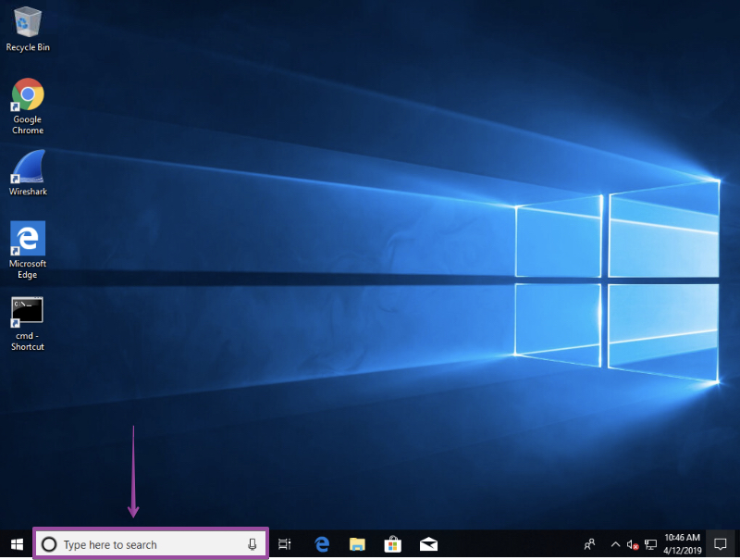

1. **Type**windows featuresin the Search box.

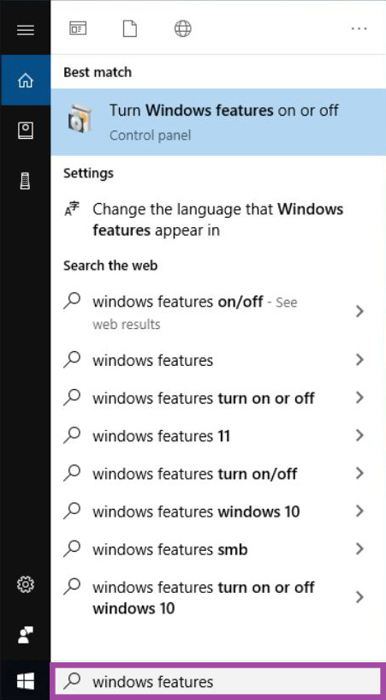

1. **Click**on Turn Windows features on or off.

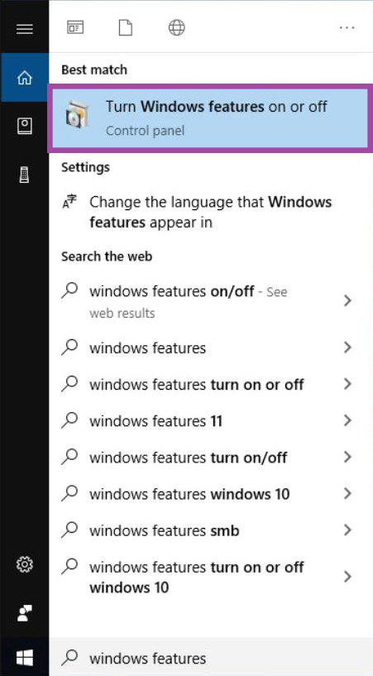

1. Make sure theHyper-V checkbox is checked.

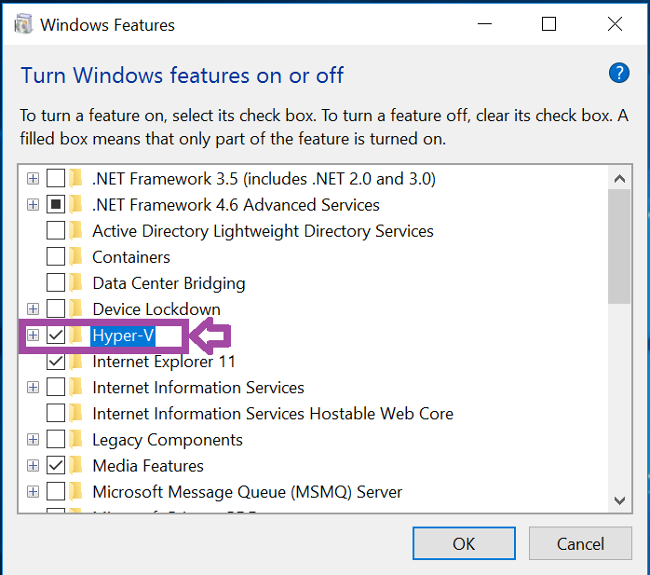

1. **Click** on OK.

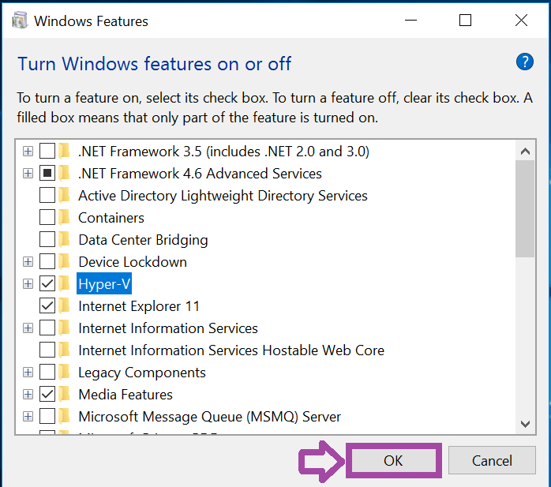

Create a Virtual Machine in Hyper-V in Windows 10

1. **Click** in the Search Box.



1. **Type** Hyper-V Manager in the Search box.

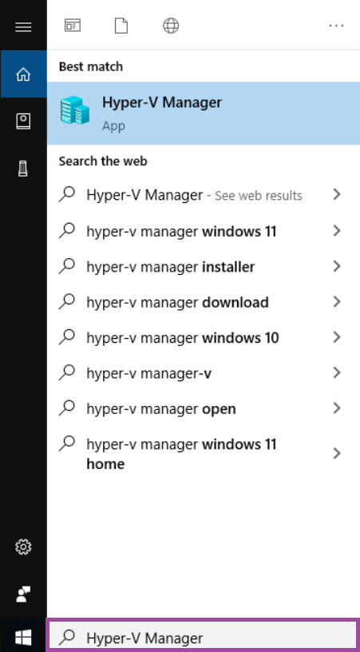

1. **Click** on Hyper-V Manager to manage virtual machines.

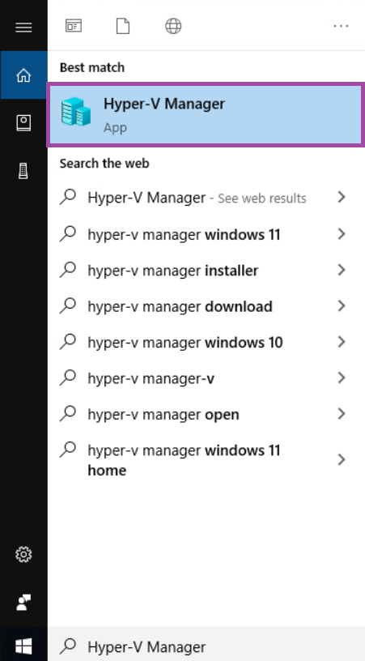

1. **Click** on the WIN10X86-002 icon to configure the machine.

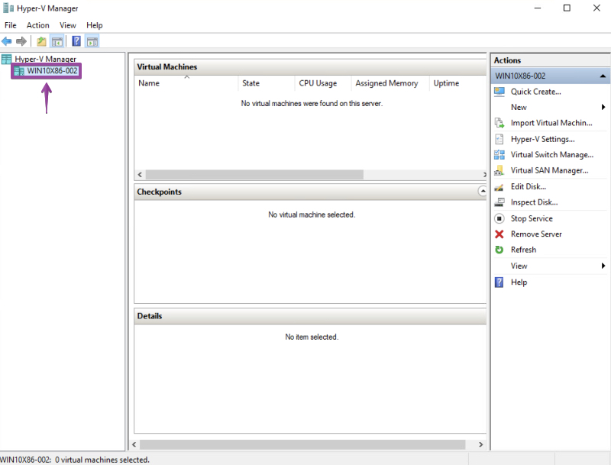

1. **Click** on Action.

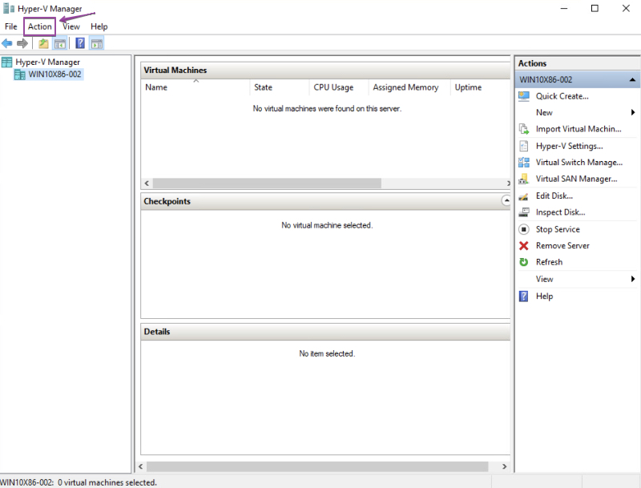

1. **Click** on Virtual Switch Manager.

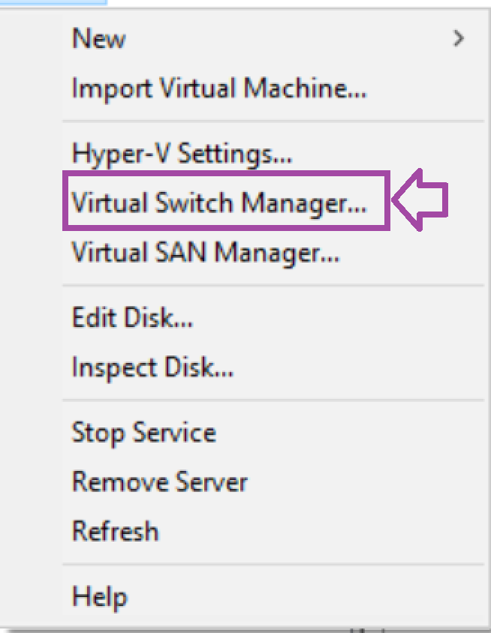

You have three options: external, internal, and private. External allows VMs to communicate with the external network. Internal allows VMs to communicate with each other and the host. Private allows VMs to communicate with each other privately.

1. **Click** on Create Virtual Switch.

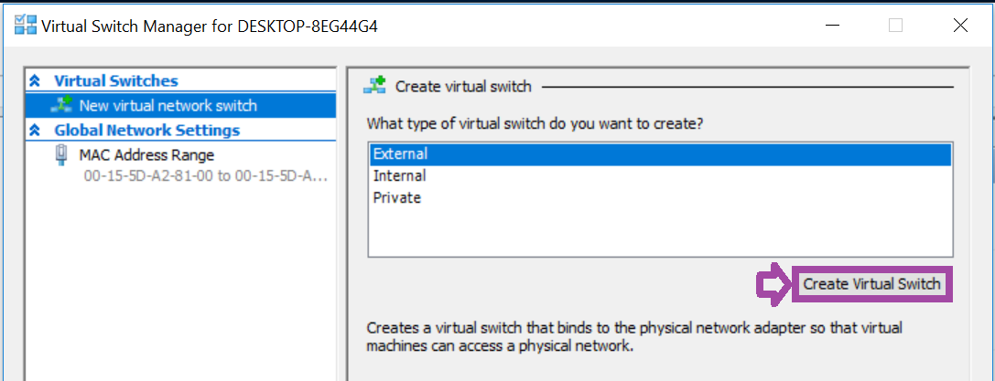

1. **Type** STUDENT-SW in the Name text box.

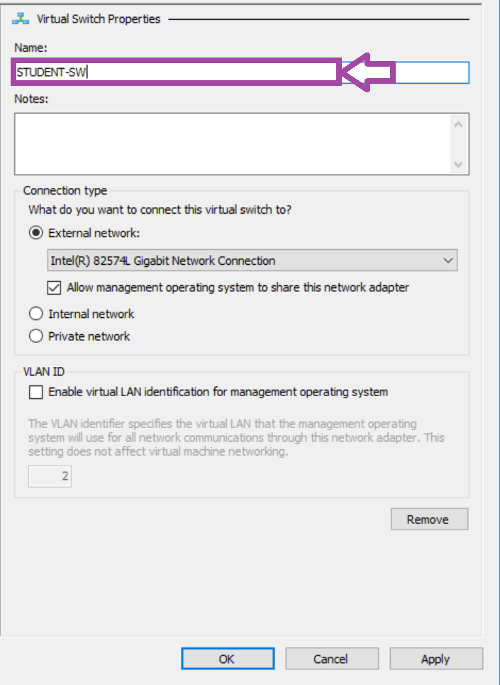

1. **Click** on OK to create the switch.

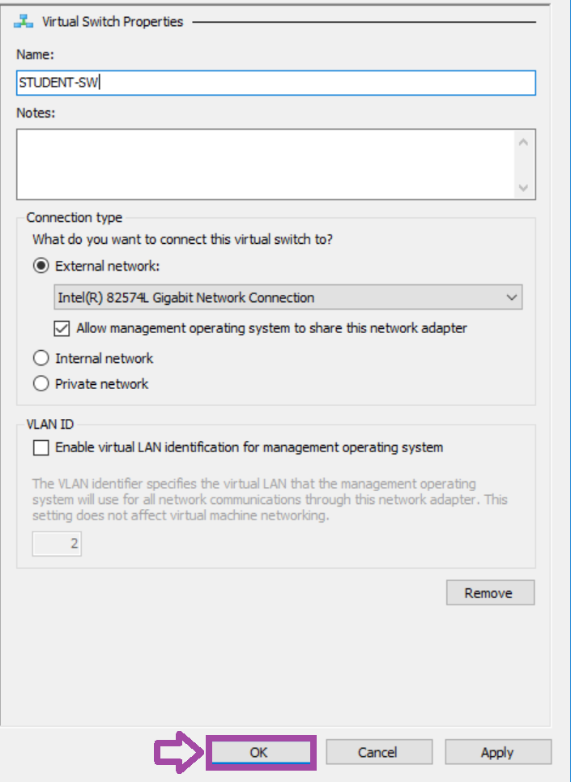

1. **Click** on Yes.

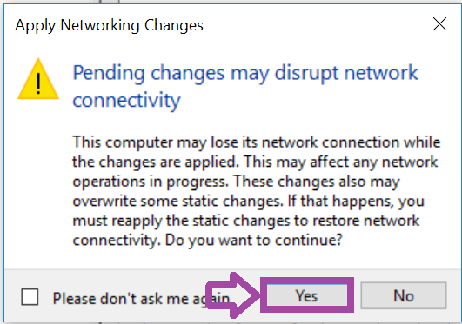

1. **Click** on New in the Actions panel to create a virtual machine.

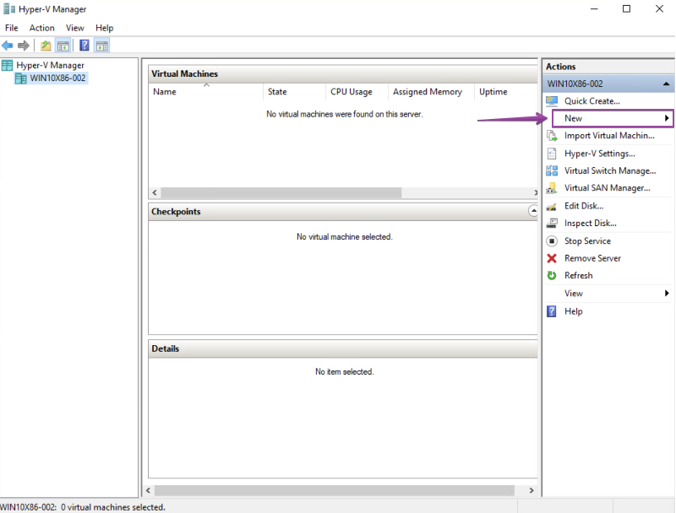

1. **Click** on Virtual Machine.

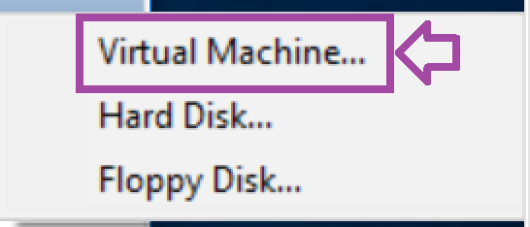

1. **Click** on Next.

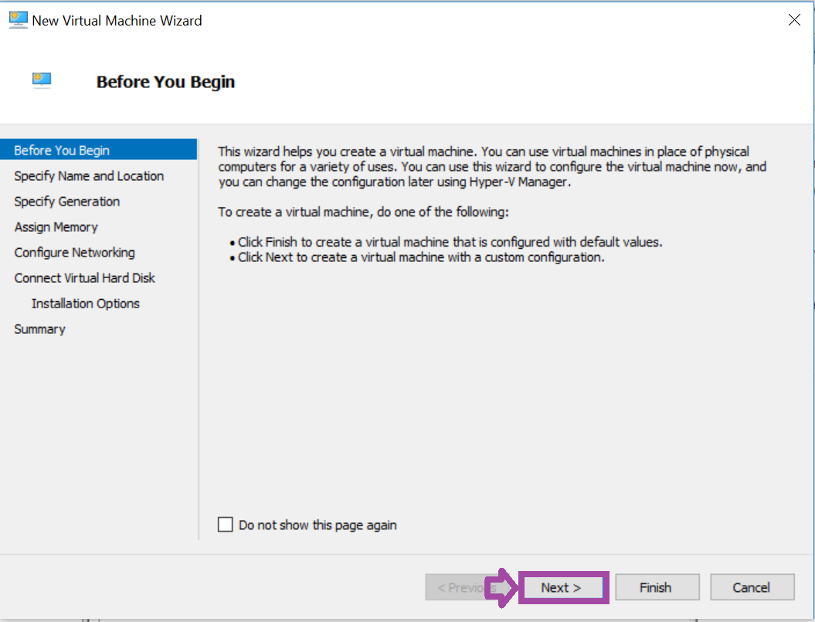

1. **Type** Windows10-VM in the Name text box.

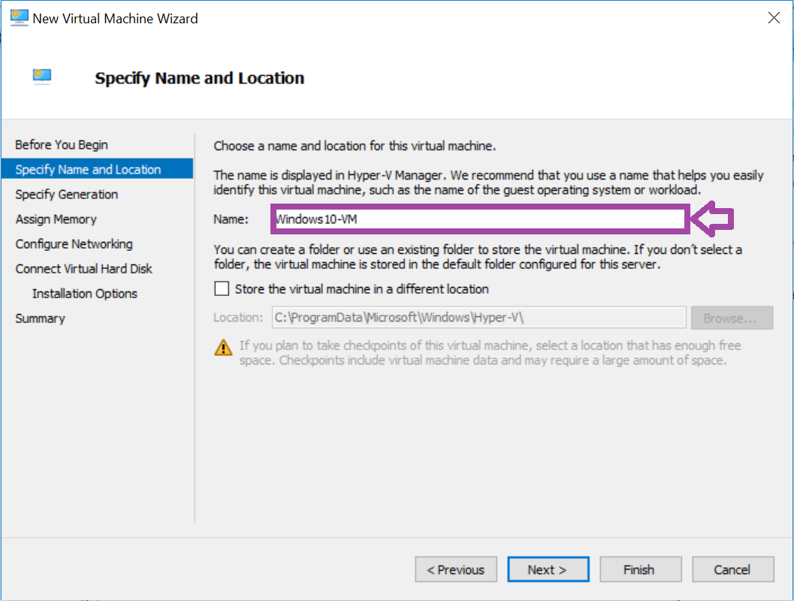

1. **Click** on Next.

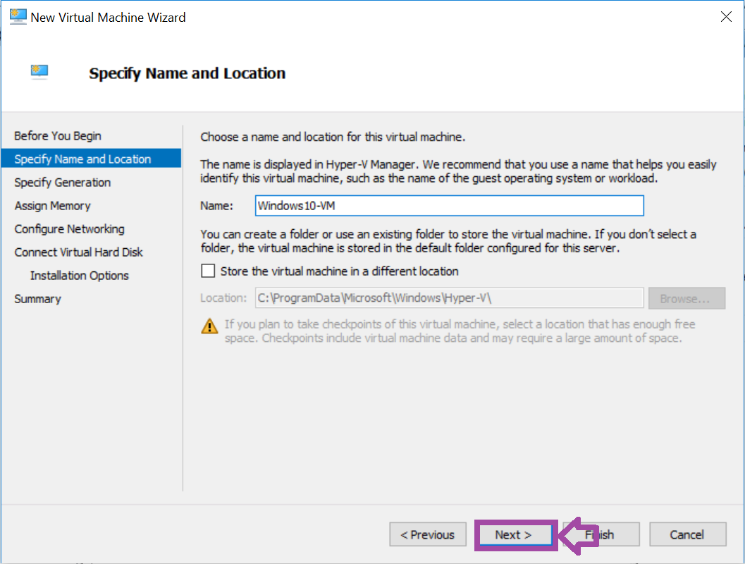

1. **Click** on Next.

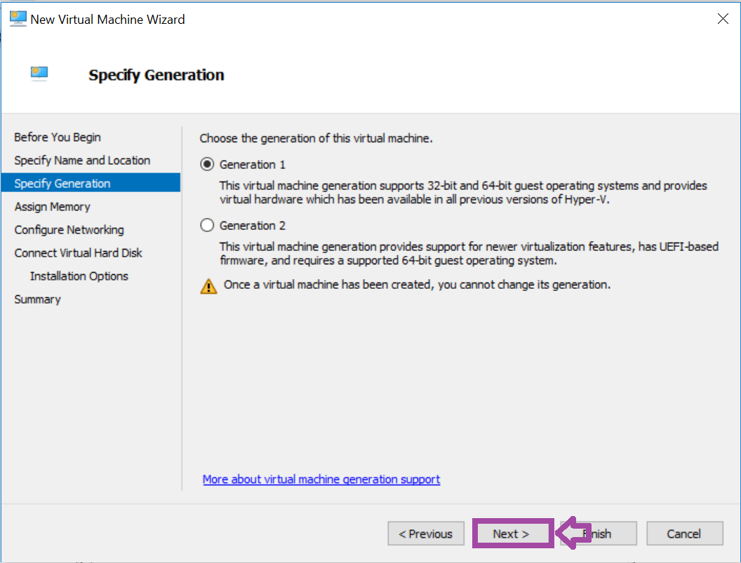

1. **Click** on Next.

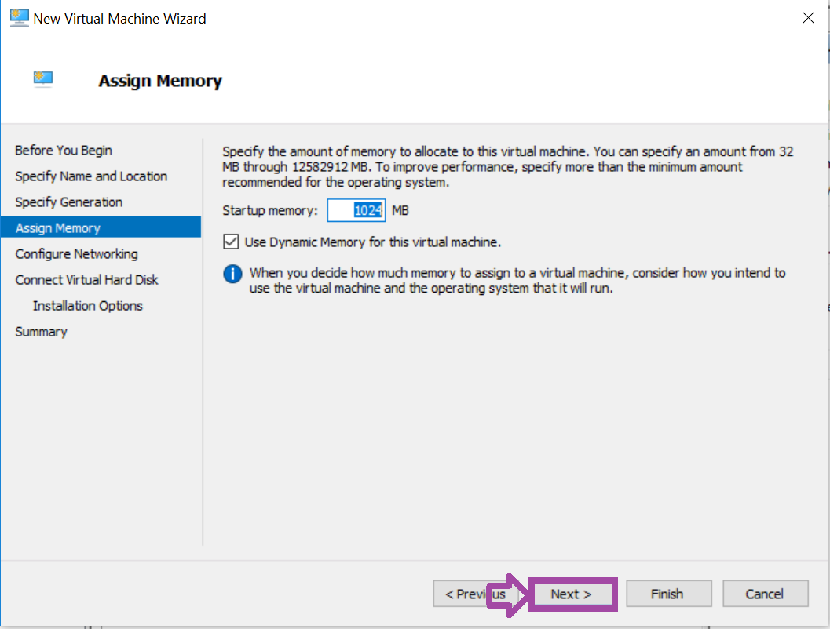

1. **Click** on STUDENT-SW for the connection. This allows the VM to connect to the STUDENT-VM switch.

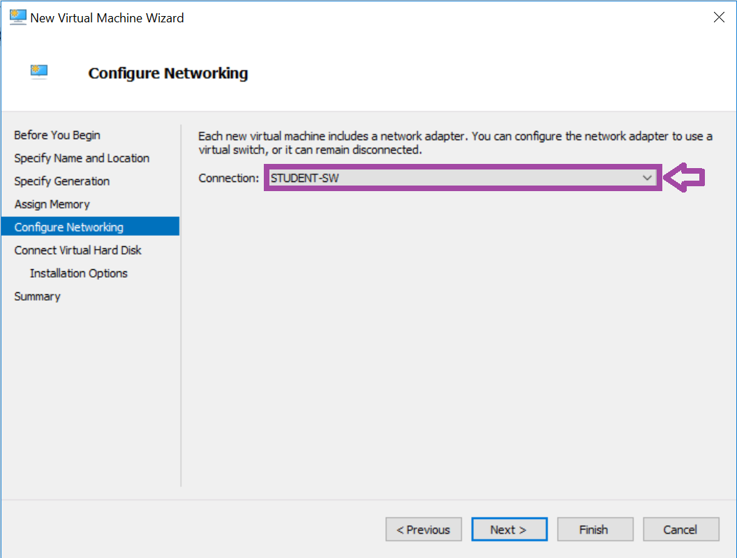

1. **Click** on Next.

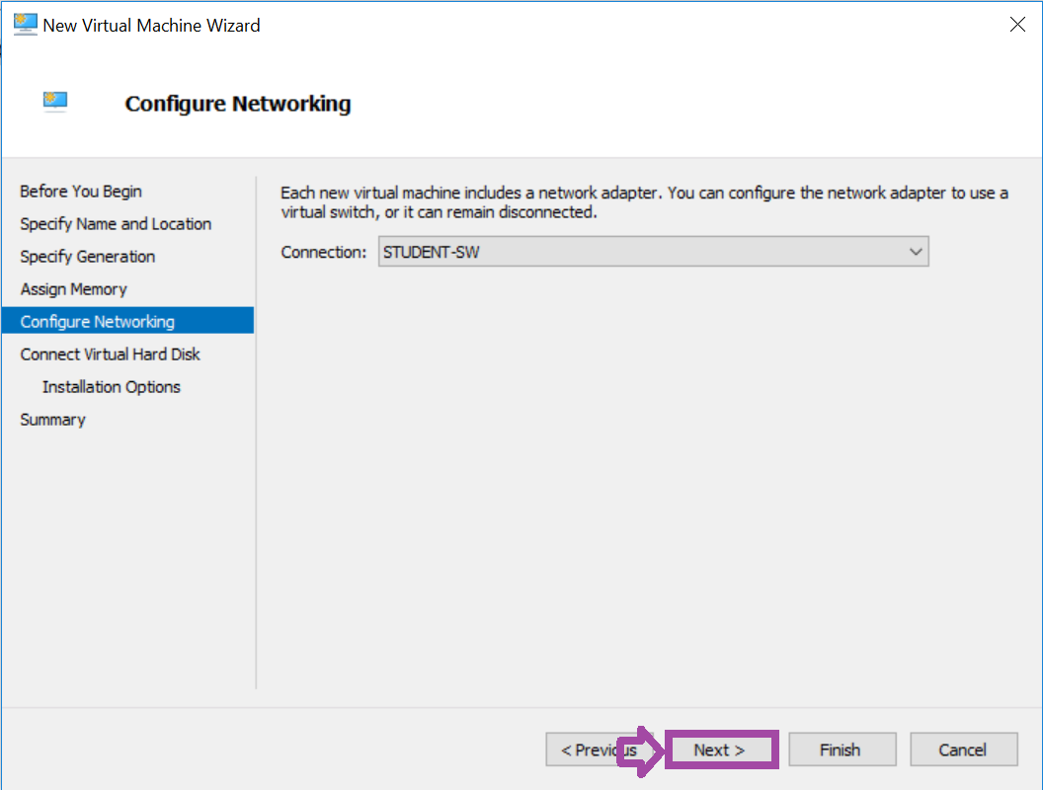

1. **Click** on Next for defaults.  **Notice** the Size of hard disk space.

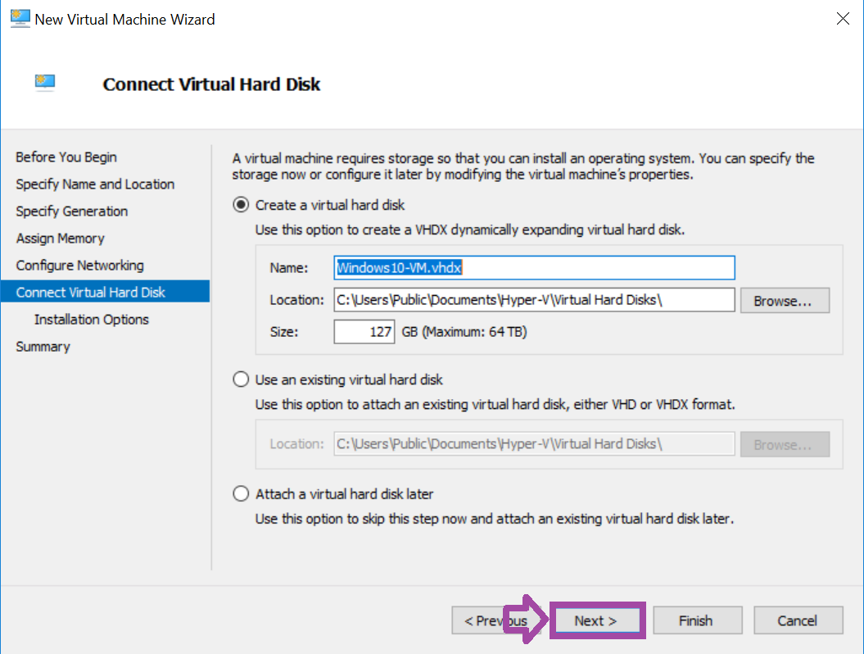

CHALLENGE #3

1. **Click** on Install an operating system from a bootable CD/DVD-ROM. An ISO file is the type of file that you will select.

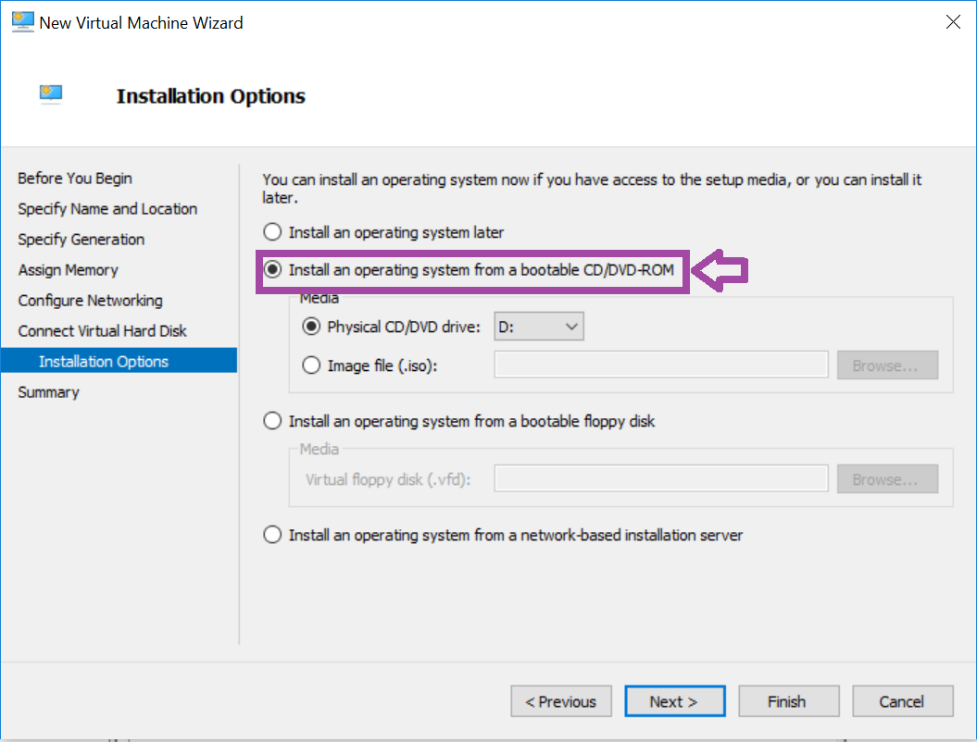

1. **Click** on Image file (.iso).

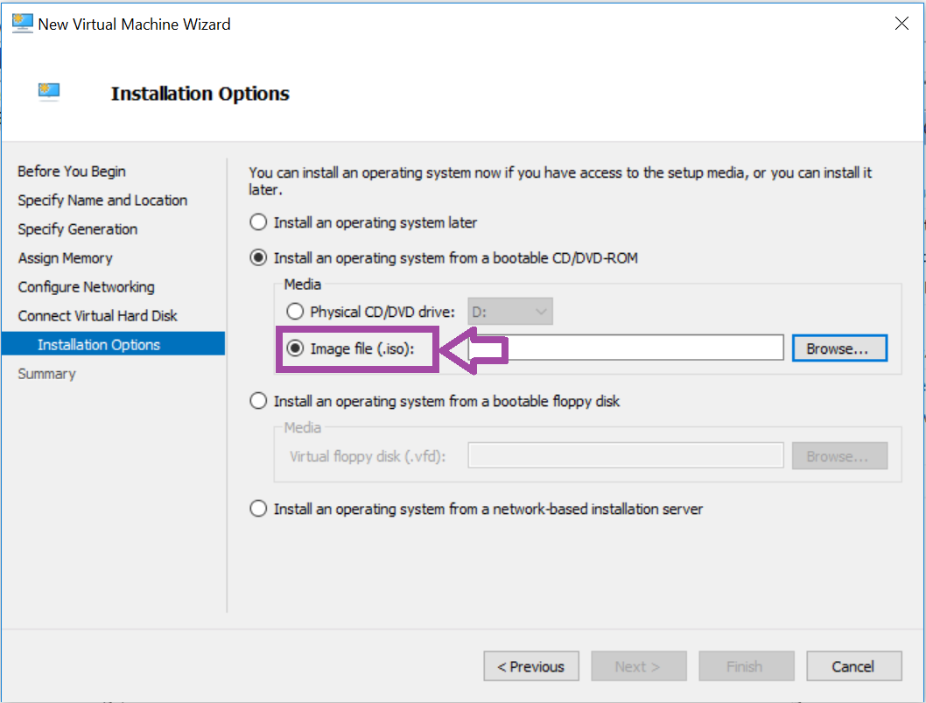

1. **Click** on Browse.

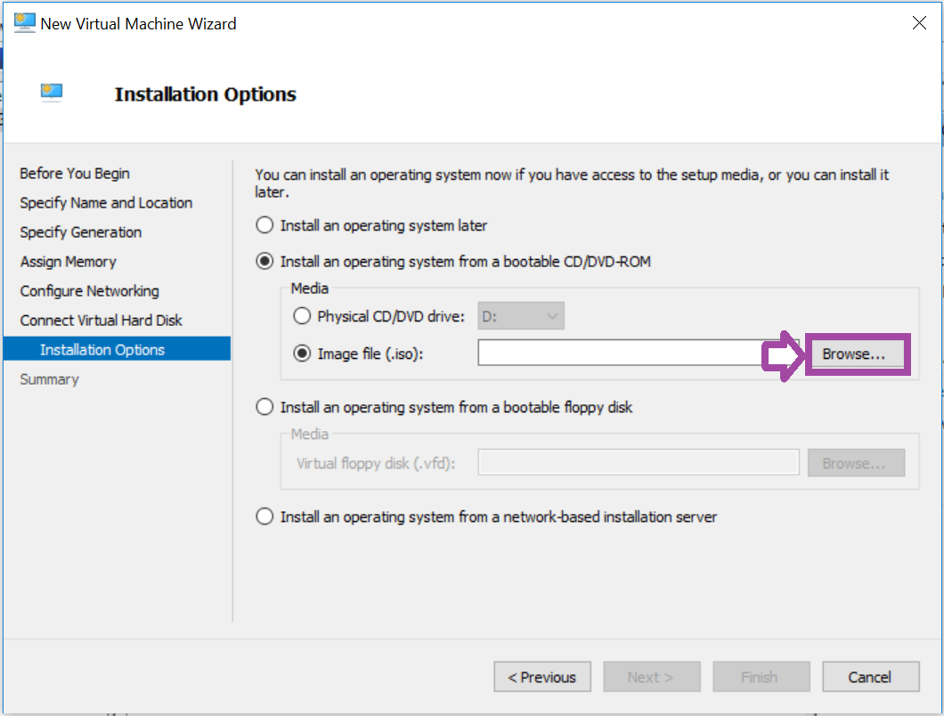

1. **Double-click** on Documents.

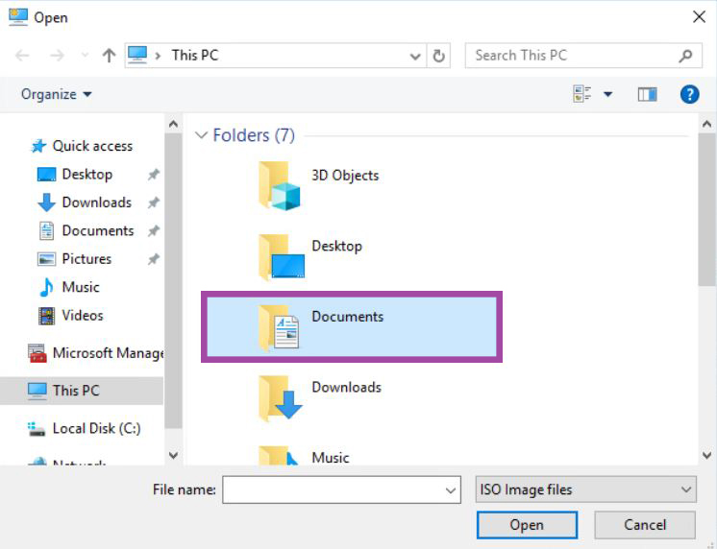

1. **Select** the Windows 10 image.

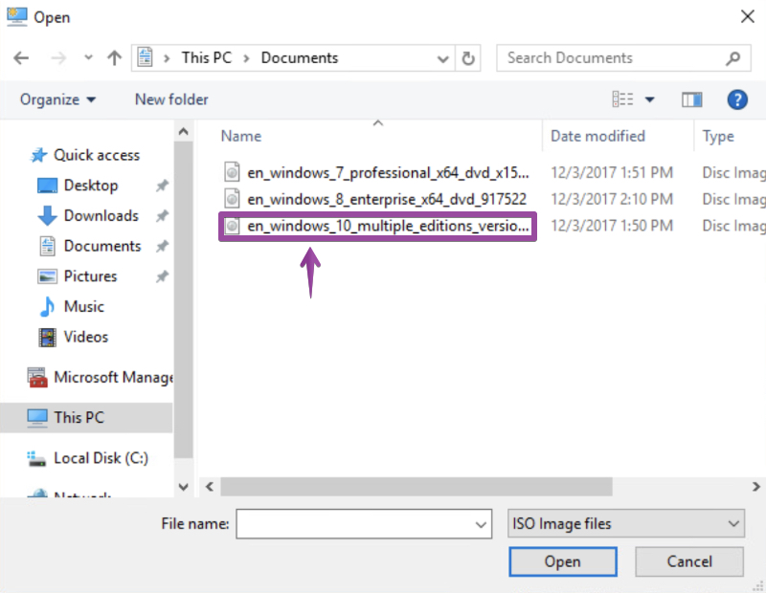

1. **Click** on Open.

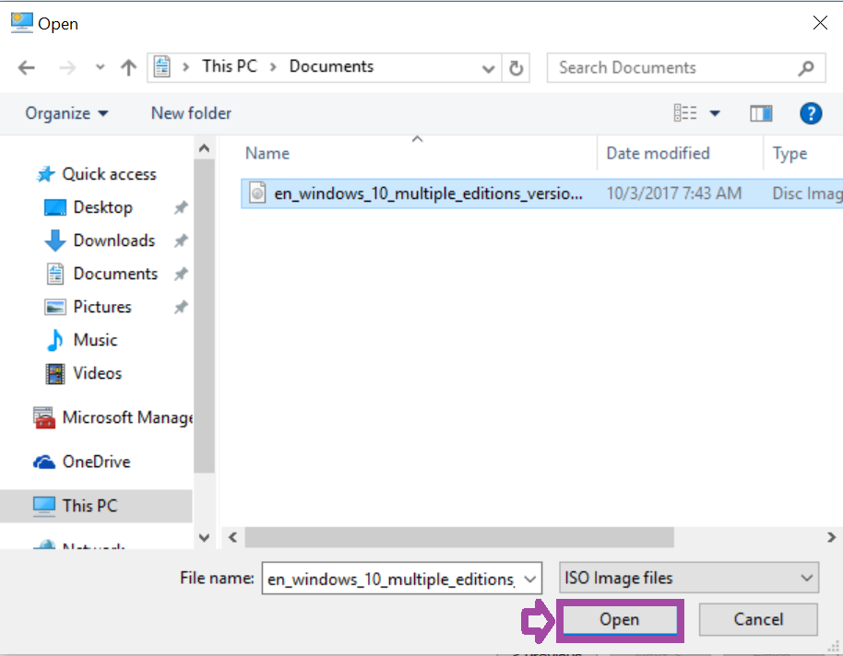

1. **Click** on Next.

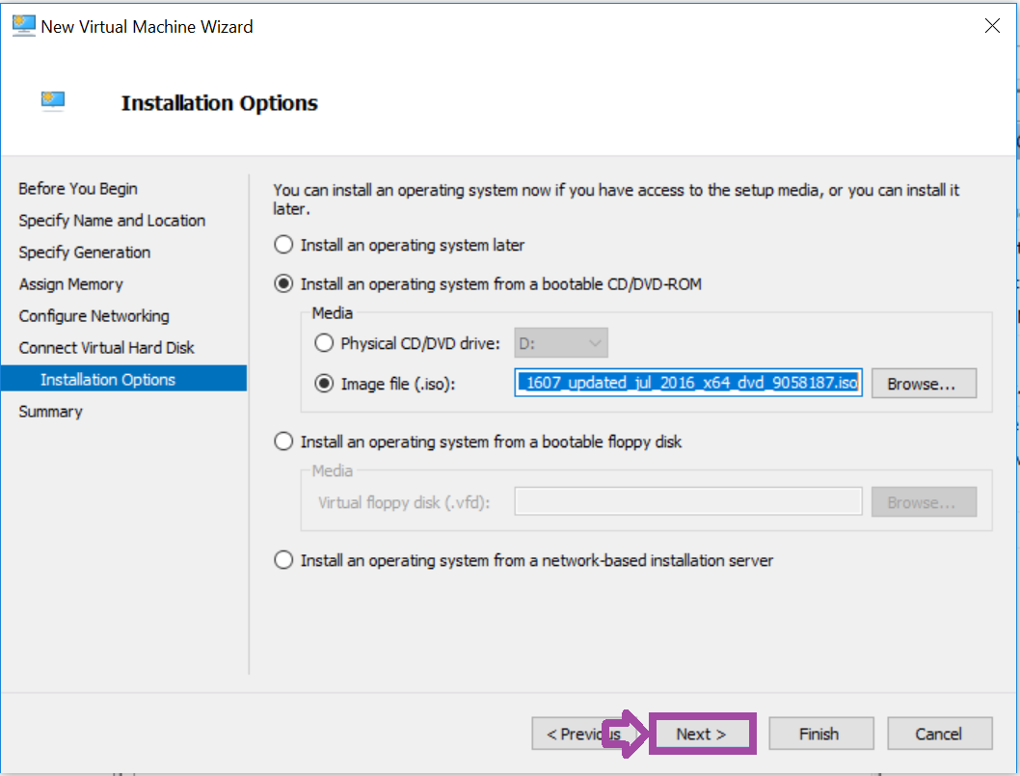

1. **Click** on Finish.

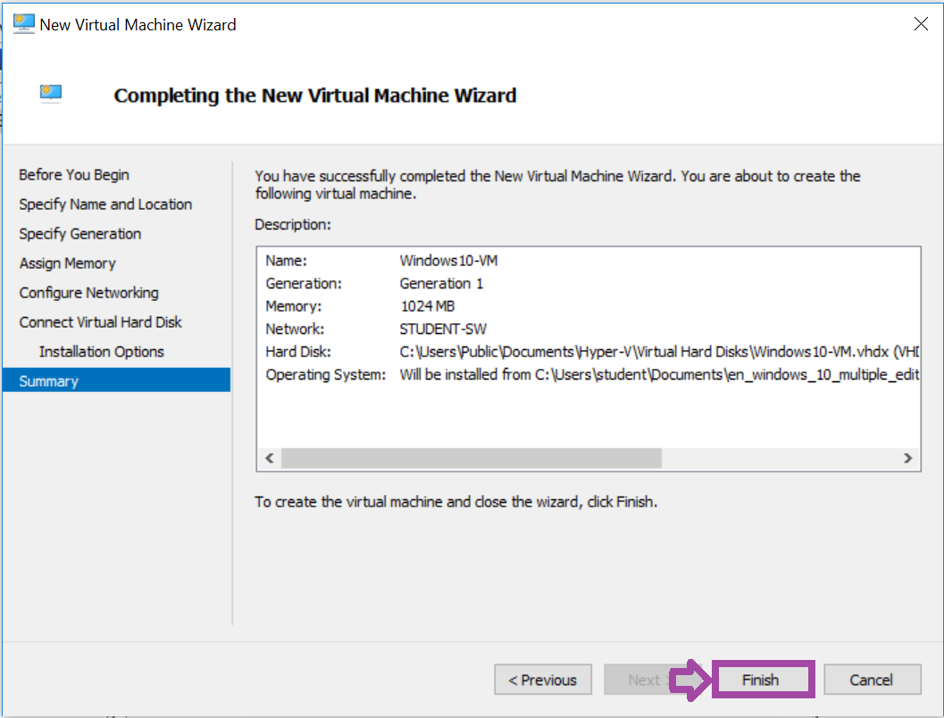

You have created a Windows 10 virtual machine. You are ready to start the virtual machine to being installed. Go to the Windows installation lab to learn how to install Windows 10.

CHALLENGE #4

1. **Click**on the X button to close Hyper-V Manager.

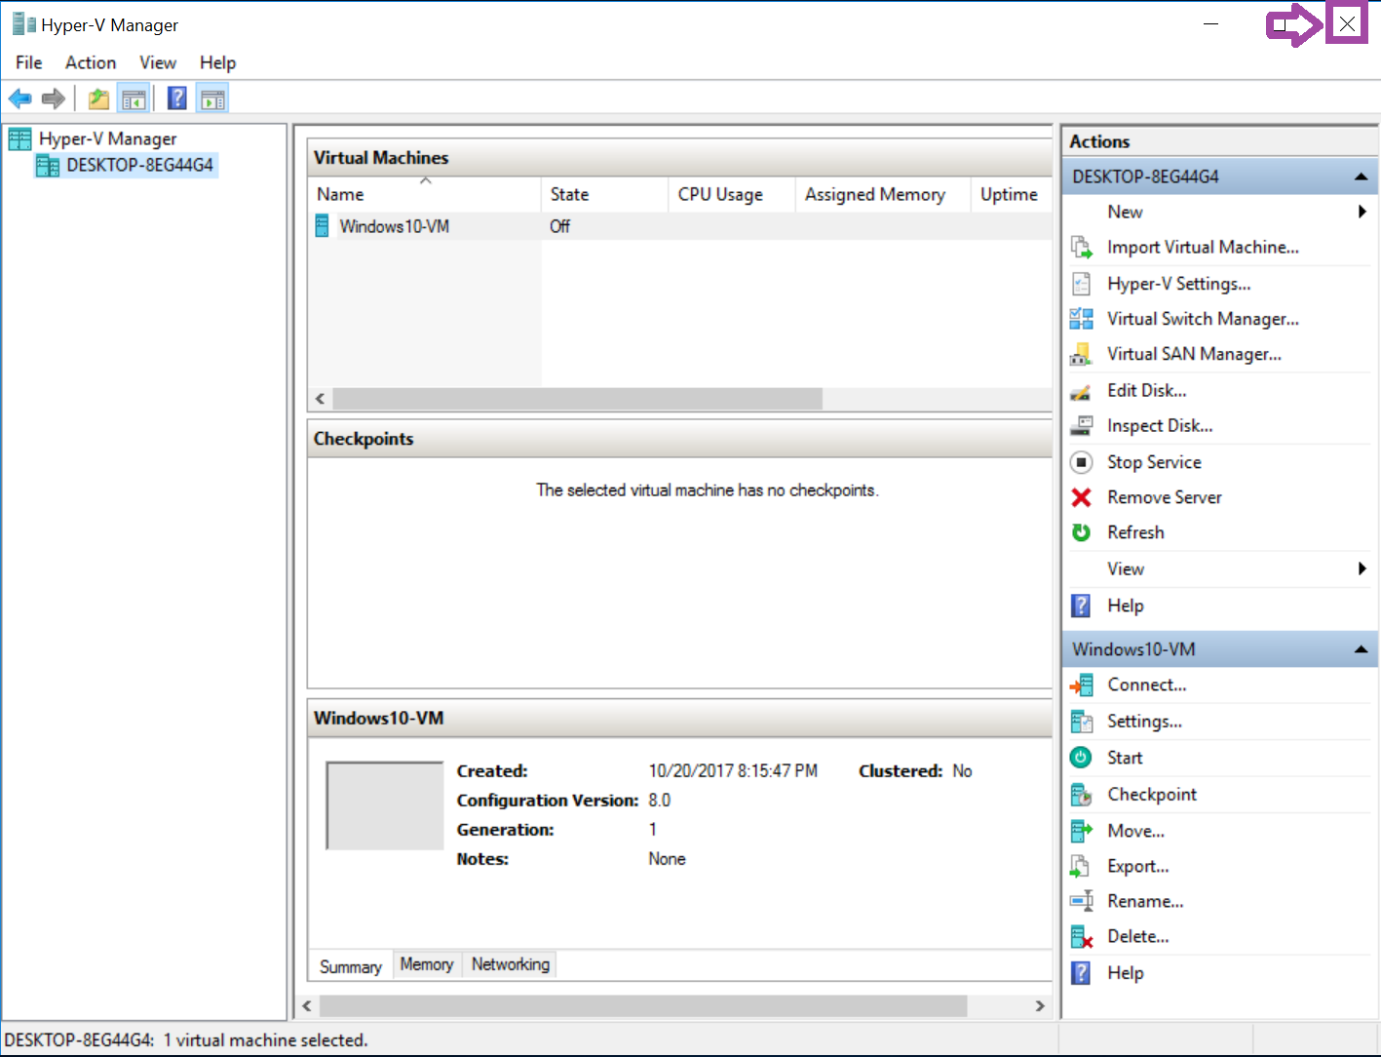

Click the STOP button on the topology to complete the lab.

**Conclusion**

This section created a virtual machine in Hyper-V for Windows 10.

**Discussion Questions**

1. What is Hyper-V?
2. What is a virtual switch?
3. What is its function?